Opening the app

Clicking to begin order

Wrote name to activate submitname button and pressed submit button to activate add to order button

Added to order to activate next button

Pressed the next button to bring up order info page

Pressed check order button

Pressed reset order

Repeated steps to activate next button and hit next

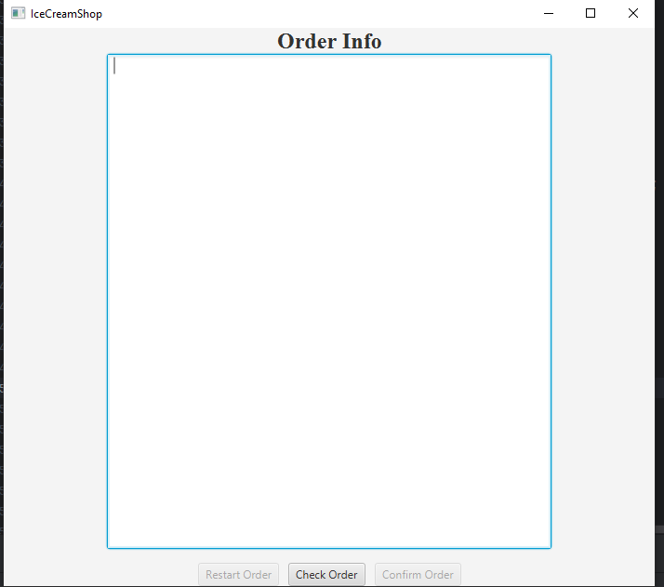

Pressed check info button

Pressed confirm order

